**MySQL Queries Screen Shot:**

**1.Total sales $ -   
Query:**Select SUM(invoiceline.Quantity * invoiceline.UnitPrice) AS "Total Sales" FROM invoiceline; 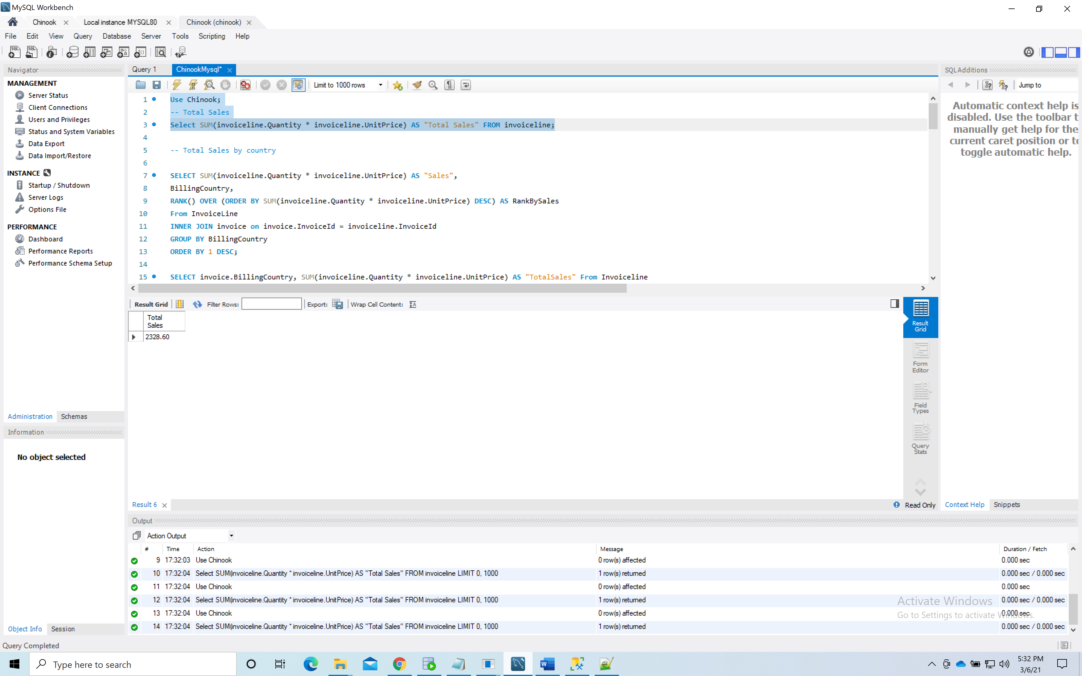

**2.Total sales $ by country –ranked (or at least sorted largest to smallest) -**SELECT SUM(invoiceline.Quantity * invoiceline.UnitPrice) AS "Sales",

BillingCountry,

RANK() OVER (ORDER BY SUM(invoiceline.Quantity * invoiceline.UnitPrice) DESC) AS RankBySales

From InvoiceLine

INNER JOIN invoice on invoice.InvoiceId = invoiceline.InvoiceId

GROUP BY BillingCountry

ORDER BY 1 DESC; 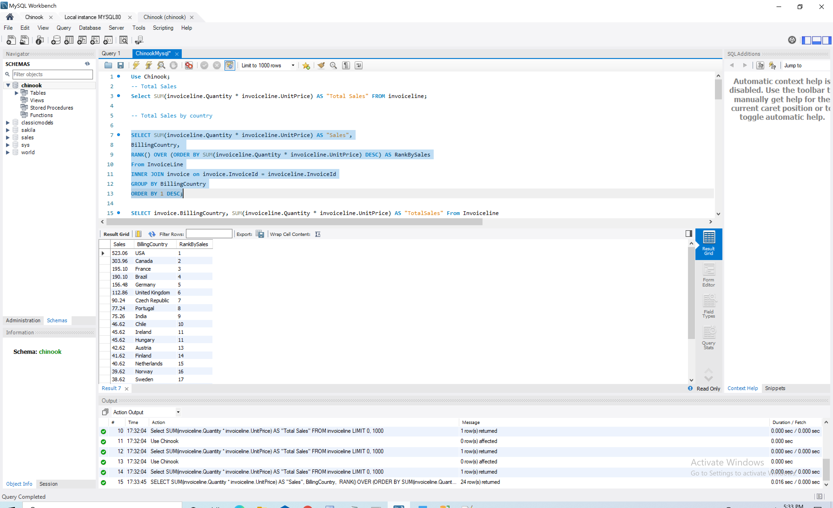

**3.Total sales $ by country, state & city -   
Query:**SELECT SUM(invoiceline.Quantity * invoiceline.UnitPrice) AS "Sales", BillingCountry,BillingCity,BillingState

From Invoice

Inner JOIN Invoiceline on invoice.InvoiceId = invoiceline.InvoiceId

Where BillingState IS NOT NULL

GROUP BY BillingCountry, BillingCity, BillingState

ORDER BY 1 DESC; 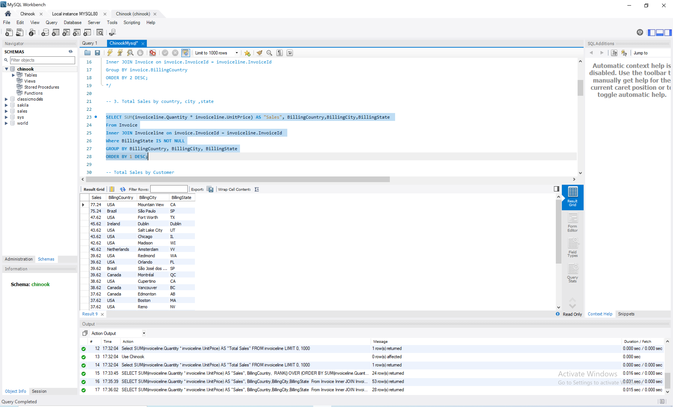

**4.Total sales $ by customer (a person with last name & first name) –ranked (or at least sorted largest to smallest)  
Query:**

SELECT FirstName,LastName, SUM(invoiceline.Quantity * invoiceline.UnitPrice) AS "Sales",

RANK() OVER (ORDER BY SUM(invoiceline.Quantity * invoiceline.UnitPrice) DESC) AS RankBySales

FROM Customer

INNER JOIN Invoice on Invoice.CustomerId = Customer.CustomerId

INNER JOIN Invoiceline on invoice.InvoiceId = invoiceline.InvoiceId

GROUP BY FirstName, LastName

ORDER BY 3 DESC; 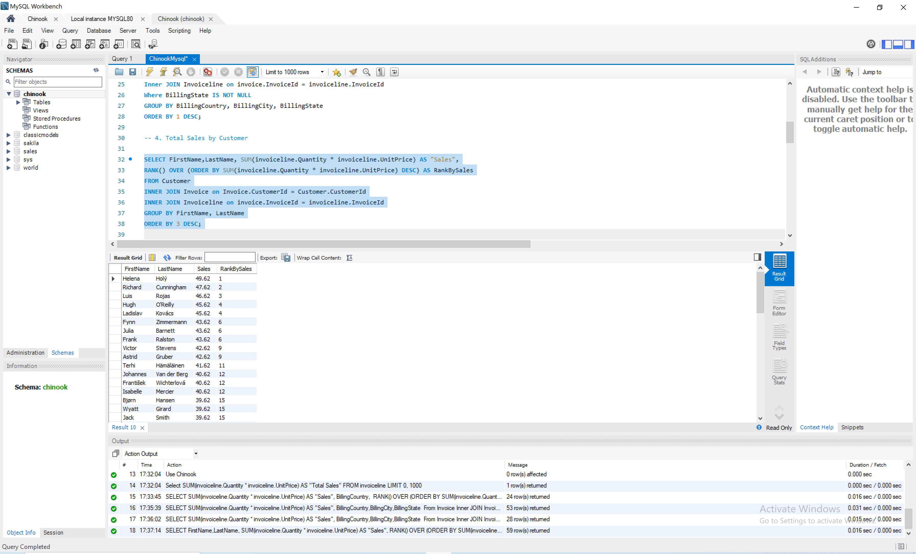

**5.Total sales $ by artist –ranked (or at least sorted largest to smallest)  
Query:**

SELECT Artist.Name, SUM(invoiceline.Quantity * invoiceline.UnitPrice) AS "Sales",

RANK() OVER (ORDER BY SUM(invoiceline.Quantity * invoiceline.UnitPrice) DESC) AS RankBySales

From Artist

INNER JOIN Album ON Album.ArtistId = Artist.ArtistId

INNER JOIN Track ON Track.AlbumId = Album.AlbumId

INNER JOIN InvoiceLine ON InvoiceLine.TrackId = Track.TrackId

INNER JOIN Invoice ON Invoice.InvoiceId = InvoiceLine.InvoiceId

Group by Artist.Name

ORDER BY 2 DESC; 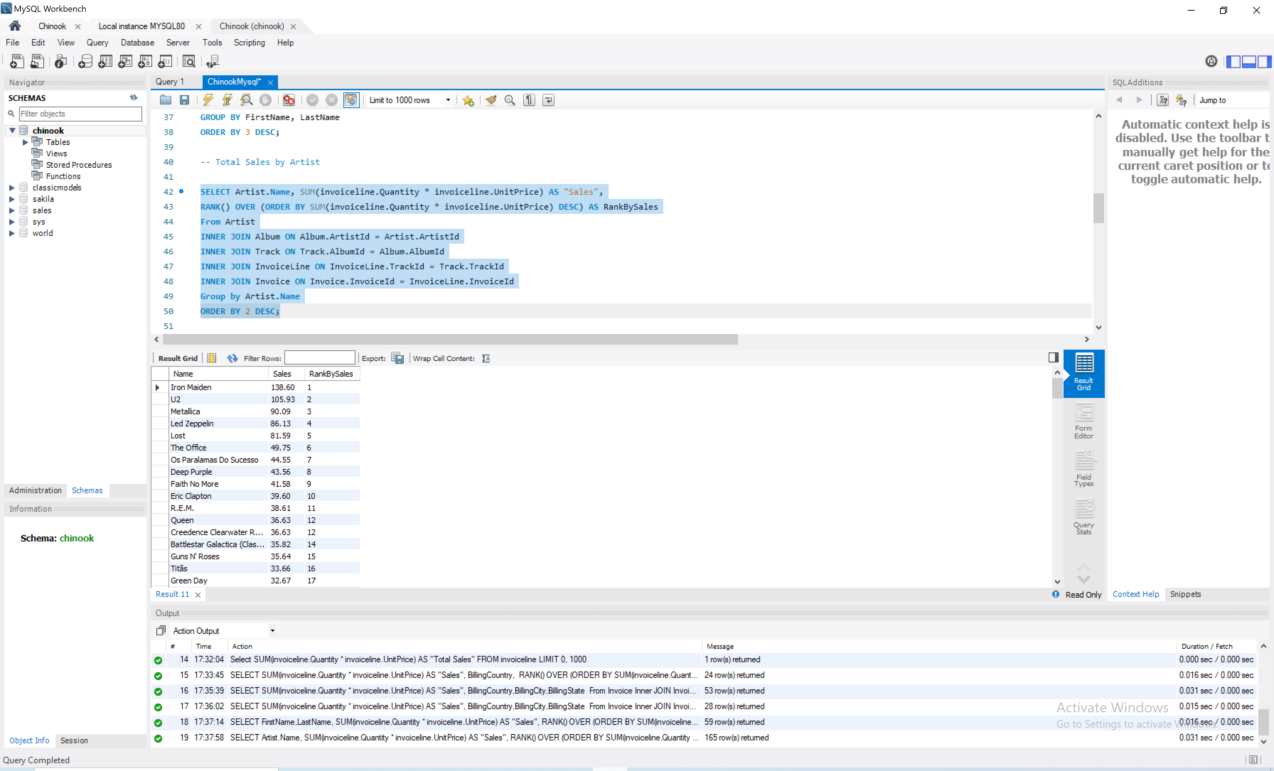

**6.Total sales $ by albums  
Query:**SELECT Album.Title as "Album", SUM(invoiceline.Quantity * invoiceline.UnitPrice) AS "Sales" From Album

INNER JOIN Track ON Track.AlbumId = Album.AlbumId

INNER JOIN InvoiceLine ON InvoiceLine.TrackId = Track.TrackId

INNER JOIN Invoice ON Invoice.InvoiceId = InvoiceLine.InvoiceId

Group by Album.Title

ORDER BY 2 DESC; 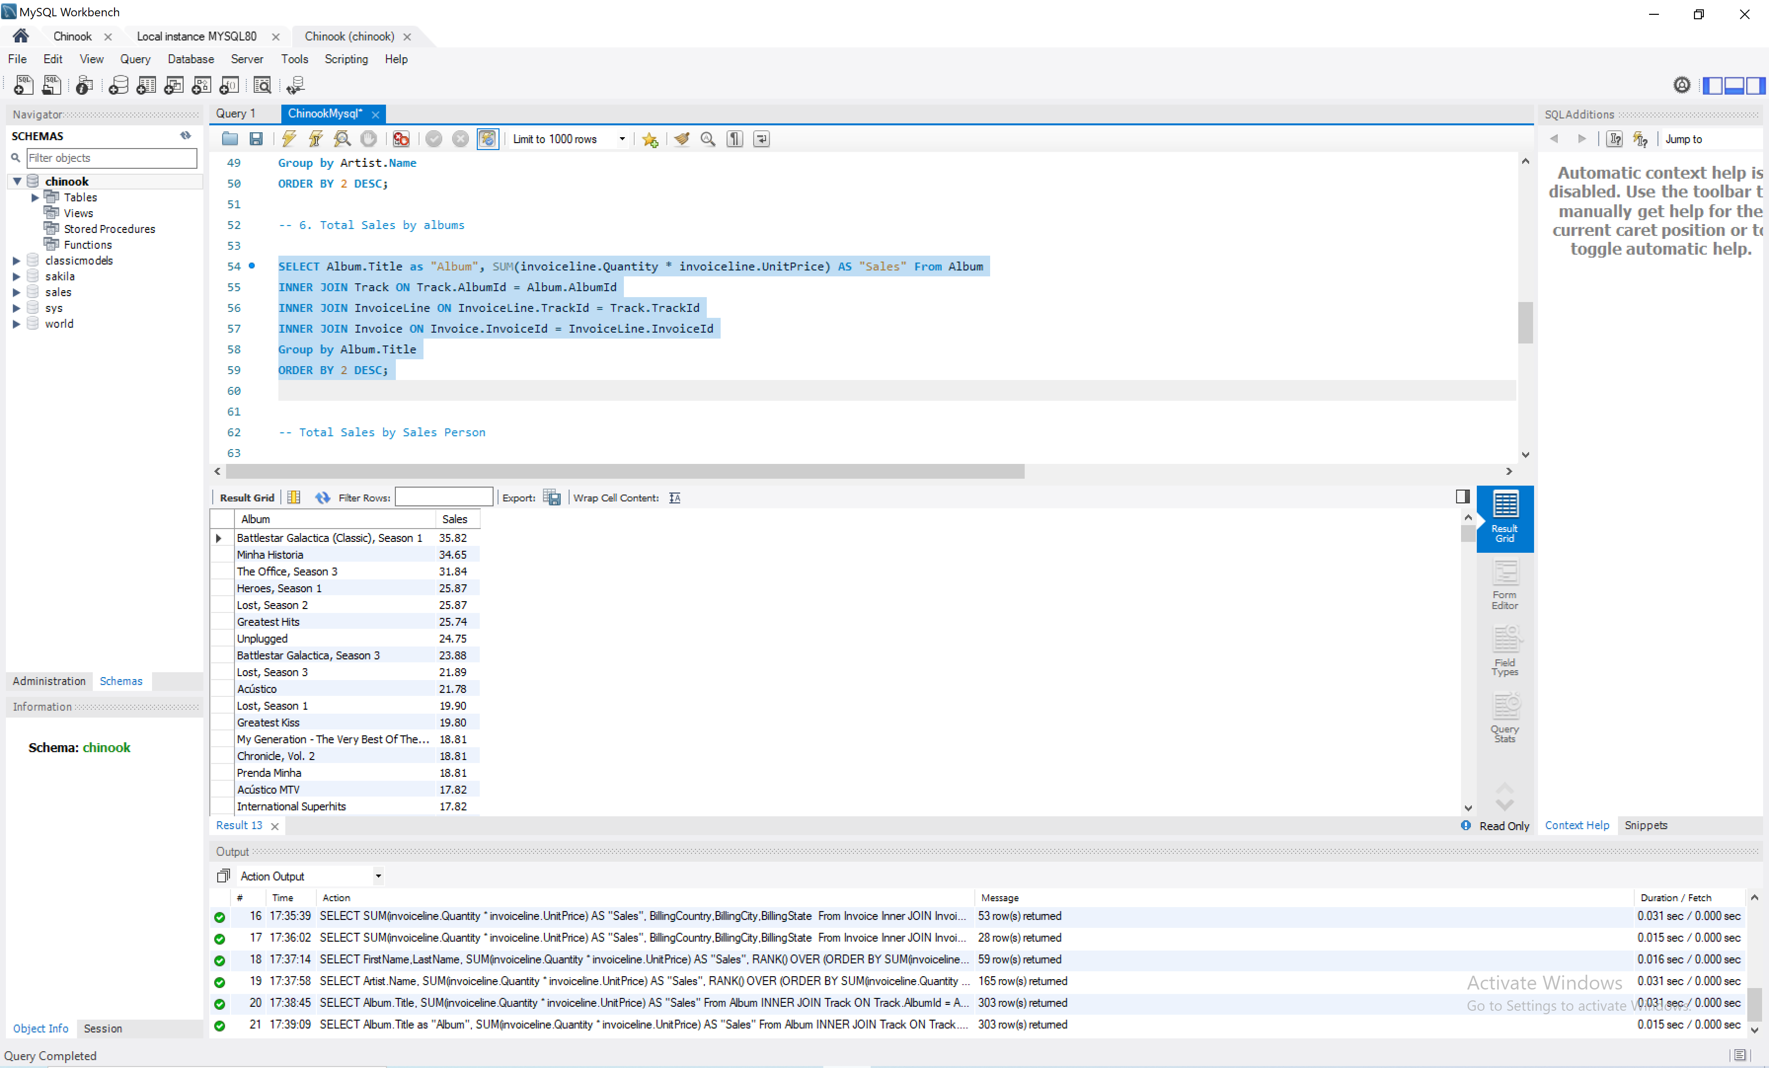

**7.Total sales $ by salesperson (employee)  
Query:**

SELECT CONCAT(Employee.LastName, ', ', Employee.FirstName) as "Sales Person",

SUM(unitprice * quantity) AS Total_Sales

FROM InvoiceLine

INNER JOIN Invoice on InvoiceLine.InvoiceId = Invoice.InvoiceId

INNER JOIN Customer on Invoice.CustomerId = Customer.CustomerId

INNER JOIN Employee ON Customer.SupportRepId = Employee.EmployeeId

GROUP BY CONCAT(Employee.LastName, ', ', Employee.FirstName)

Order by SUM(unitprice * quantity) DESC; 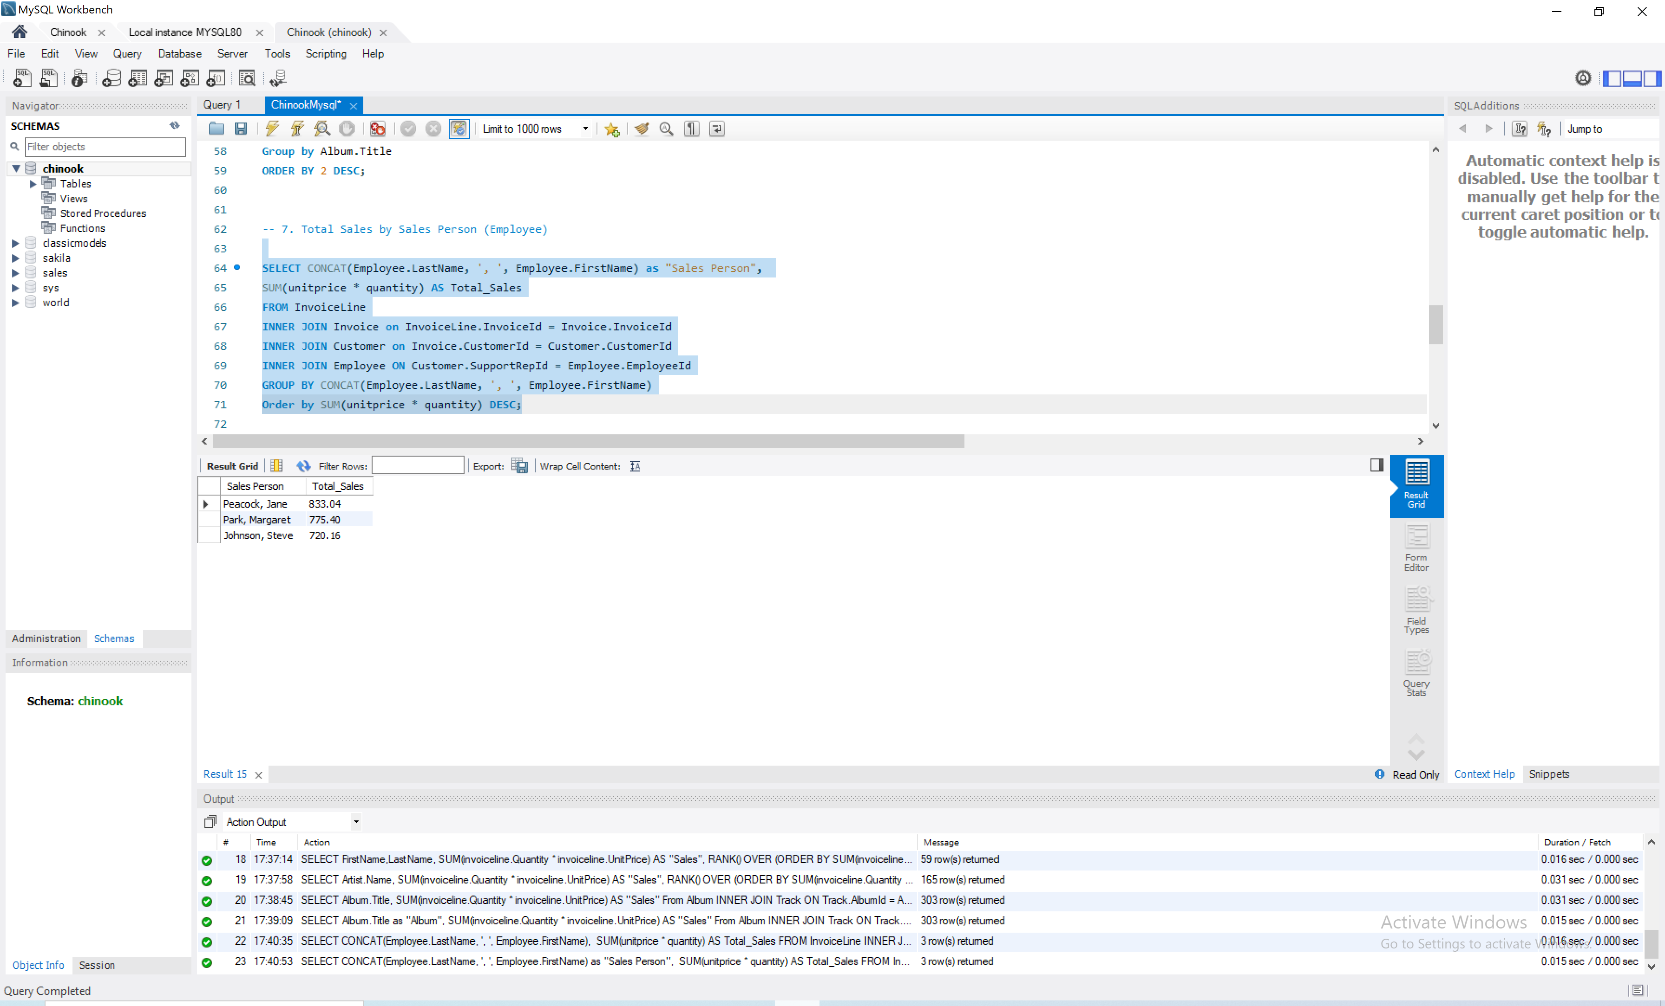

**8.Total tracks bought and total revenue $ by media type  
Query:**SELECT MediaType.Name, COUNT(InvoiceLine.TrackId) AS "Tracks Bought", SUM(invoiceline.Quantity * invoiceline.UnitPrice) AS "Sales" From Track

INNER JOIN MediaType ON MediaType.MediaTypeId = Track.MediaTypeId

INNER JOIN InvoiceLine ON Track.TrackId = InvoiceLine.TrackId

INNER JOIN Invoice ON Invoice.InvoiceId = InvoiceLine.InvoiceId

GROUP BY MediaType.Name

ORDER BY 2 DESC; 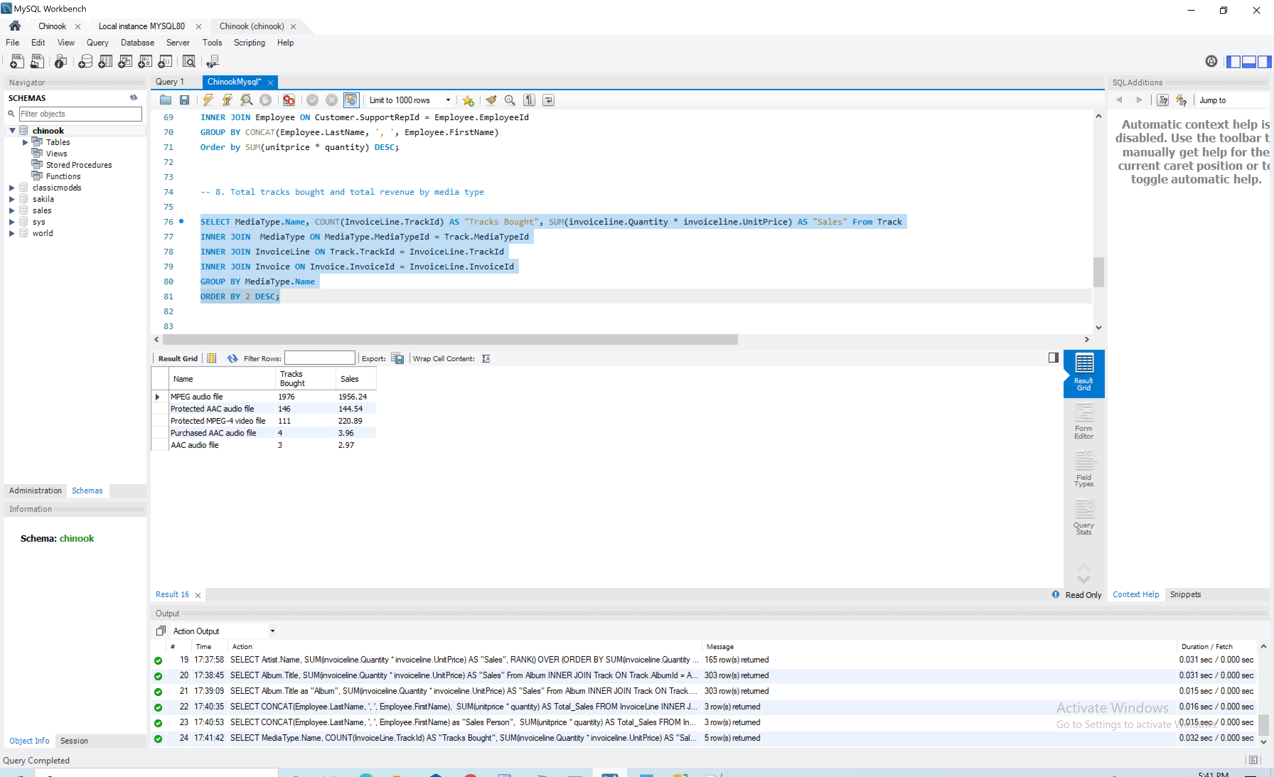

**9.Total sales $ by genre  
Query:**

SELECT Genre.Name as "Genre", SUM(invoiceline.Quantity * invoiceline.UnitPrice) AS "Sales" From Genre

INNER JOIN Track ON Track.GenreId = GENRE.GenreId

INNER JOIN InvoiceLine ON InvoiceLine.TrackId = Track.TrackId

INNER JOIN Invoice ON Invoice.InvoiceId = InvoiceLine.InvoiceId

Group by Genre.Name

ORDER BY 2 DESC; 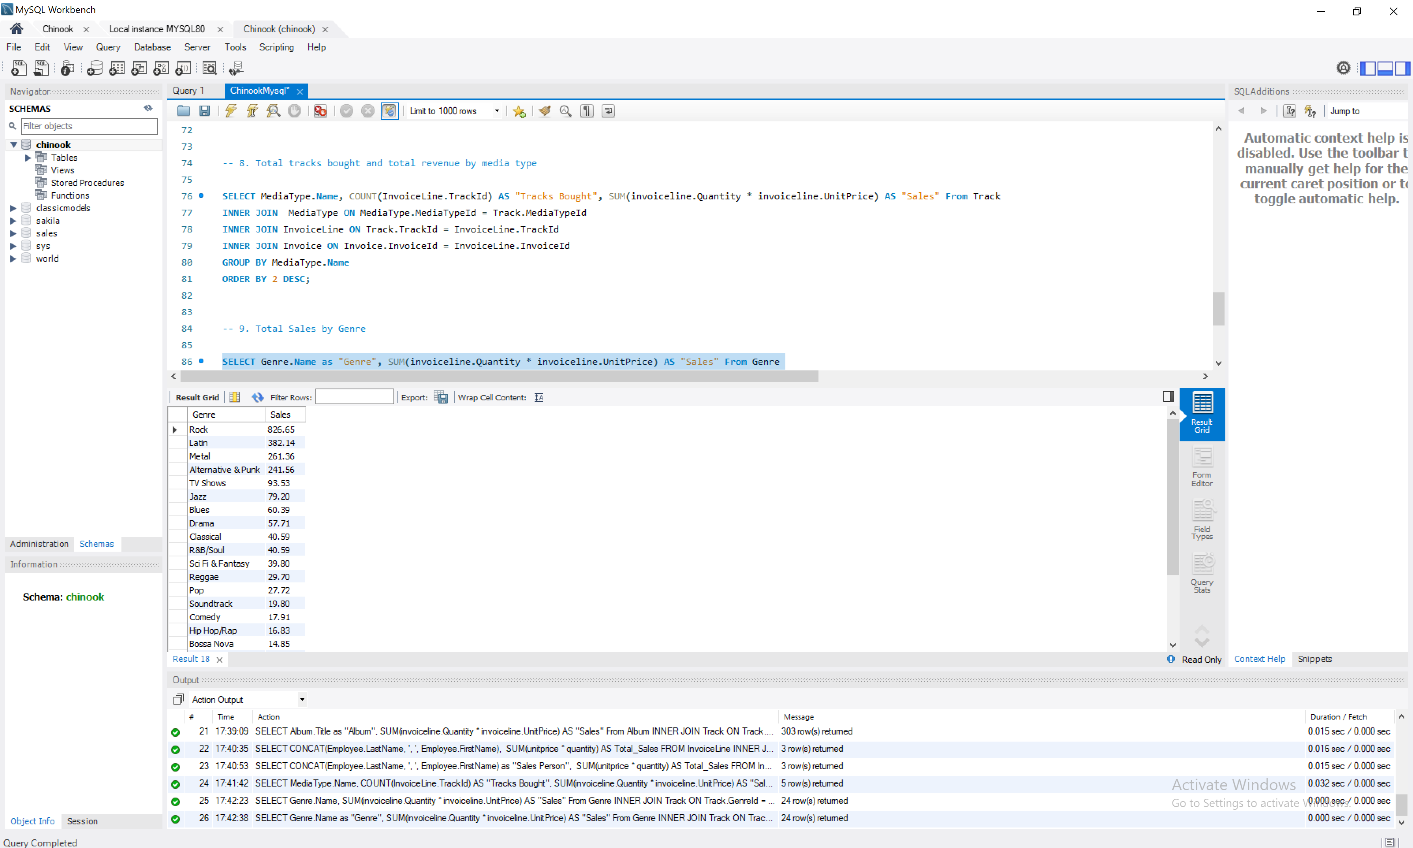

**10.Total sales $ by company**

**Query:**

SELECT CONCAT(Customer.LastName, ', ', Customer.FirstName) AS "Customer Name", Company,

SUM(unitprice * quantity) AS Sales

FROM InvoiceLine

JOIN Invoice ON InvoiceLine.InvoiceId = Invoice.InvoiceId

JOIN Customer ON Invoice.CustomerId = Customer.CustomerId

WHERE Company IS NOT NULL

GROUP BY CONCAT(Customer.LastName, ', ', Customer.FirstName), Company

Order BY 3 desc; 